Rectangular Prisms and Parfleche Bags
Subject: Mathematics Creator: Alison Kimbley
Strand: Shape and Space Grade: 4
Content (topic)

Exploring Prisms
Outcomes  SS 4.3: Demonstrate an understanding of rectangular and triangular prisms by:  - Identifying common attributes  - Comparing  - Constructing models | Indicators  SS 4.3a: Identify and name common attributes of rectangular prisms from sets of rectangular prisms.  SS 4.3f: Construct rectangular prisms from their nets.  SS 4.3h: Construct nets for rectangular or triangular prisms.
Mathematical Processes:
- Connections
- Mental Mathematics
- Spatial Sense
- Reasoning
- Visualization
Lesson Preparation
Equipment/materials:
- One piece of simulated rawhide for each student
- One sheet of legal size (8.5 in by 14 in) paper for each student
- One copy of the rectangular prism net for each student
- 1 centimeter grid printed on various colored paper for the students to share
- Scissors
- Photographs of parfleche containers in the shape of rectangular prisms
- Hole punch
- Yarn
- Glue sticks

Advanced Preparation:
- Prepare one simulated rawhide sheet for each student using the instructions provided
- Print a copy of the rectangular prism net for each student
- Print the one-centimeter grid on colored paper. Make sufficient copies for the students to share in making their parfleche bags.
Presentation
Set (3 min)
- This lesson follows Area, Symmetry and Parfleche Bags

- Explain to the students that some parfleche containers have the shape of a rectangular prism and show them the photographs below.
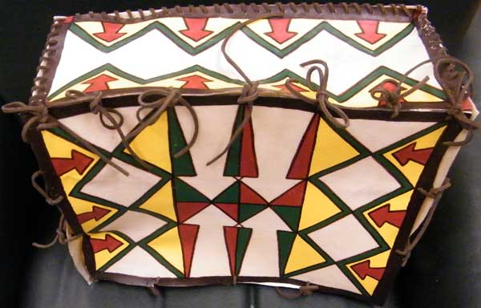

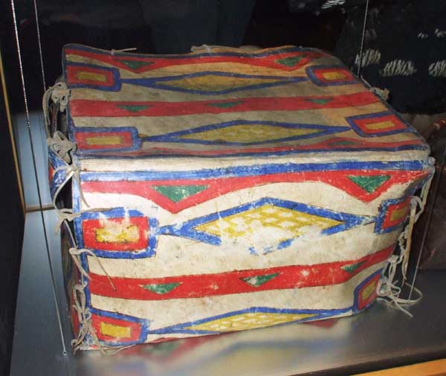

Development
- Ask students to make a list of common attributes of these prisms, for example the shape of the faces, the number of faces, the fact that they come in pairs, as well as the number of edges and vertices.
- Hand out the nets for the rectangular prism and have each student cut out the net and construct a rectangular prism. Have each student expand his or her net somewhat, draw it on the legal sized sheet of paper and cut it out to form another rectangular prism. Have each student trace this new net onto the simulated rawhide, cut it out, and fold to form a simulated parfleche container. Use the hole-punch to punch holes in the parfleche container at the point indicated in the net.
- As in the lesson Area, Symmetry and Parfleche Bags, have the students use the colored grid paper to create a symmetrical design on their parfleche bags. Fold up the bag in the shape of a rectangular prism and use the yarn to tie it closed in a fashion similar to the photographs above.

